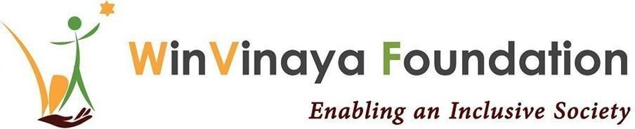

# **WinVinaya Foundation**

# **Annual Report 2023-2024**

“By end of FY 2023-24, WinVinaya Foundation trained **1200**+ candidates across 18 different disabilities in niche and industry ready skills and placed **430+** candidates with average salary double of industry average. ”

**Expanding WinVinaya’s Edu Connect Program**  
WinVinaya Foundation expanded its EduConnect program by partnering with 4 colleges across India to upskill 100 students.  
WinVinaya was delighted to sign an MOU with JSSPDA (JSS - Polytechnic for the Differently Abled), Mysuru, to upskill hundreds of college students with disabilities. JSSPDA, an outstanding institution, had received various State and National Awards for their exceptional work in empowering Persons with Disabilities.

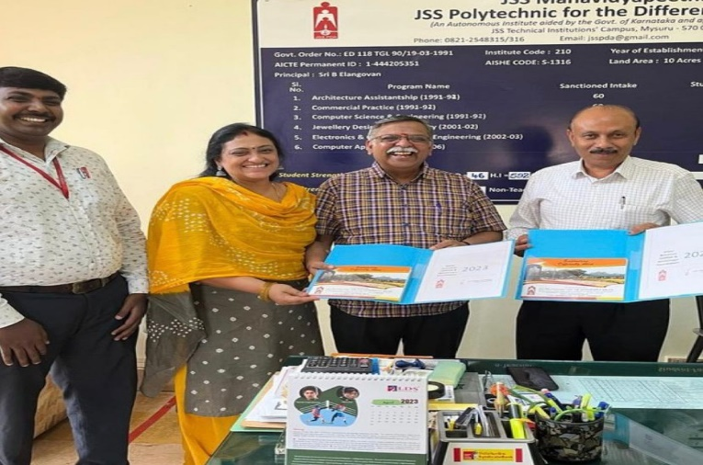

**Nature For All: A Walk with Persons with Disabilities**  
On 28 April 2023, WinVinaya Foundation hosted an inclusive event titled "Nature For All: A Walk with Persons with Disabilities" in collaboration with Wells Fargo volunteers to commemorate Earth Day. The event aimed to raise awareness of environmental issues and promote actions towards a more sustainable future in an inclusive manner.

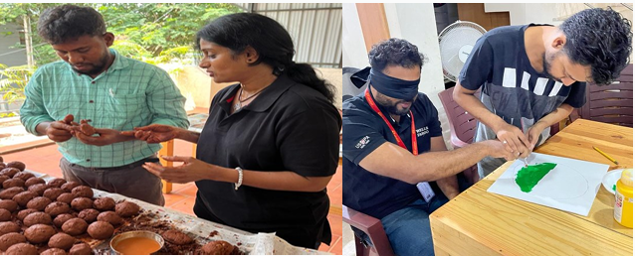

**A Celebration of Abilities**

WinVinaya Foundation teamed up with Standard Chartered Bank for the World 10K Bengaluru marathon. This extraordinary event brought together candidates with diverse disabilities, who were paired up with employees of SCB. It was a joyful celebration that focused on abilities rather than disabilities, sparking a transformative experience for all participants involved.

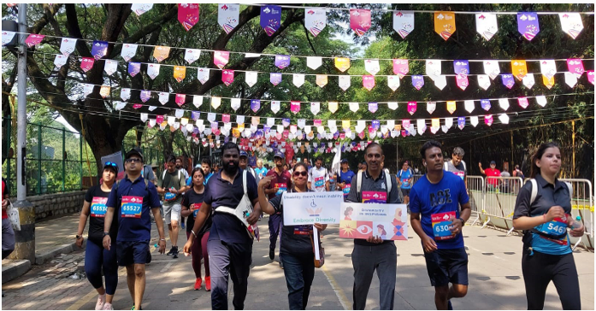

**Disability Awareness Orientation**

WinVinaya held a Disability Awareness Orientation (DAO) for CGI, this helped the employees engage, empower, and include persons with disabilities in the office. The sensitization program delved deep into disabilities, spotlighting visual, hearing, speech, and locomotor impairments through interactive activities. Participants learned sign language basics, highlighting the power of inclusive communication. Small gestures bridged gaps and integrated individuals with disabilities.

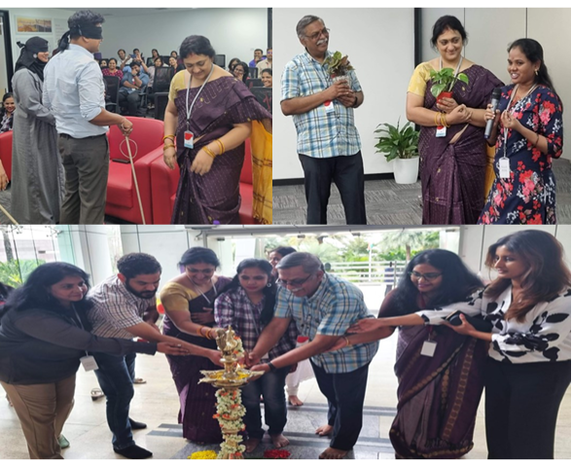

**Celebration @ WinVinaya**  
In September, WinVinaya celebrated Teacher's Day and the Onam Festival, filled with heartwarming moments as we came together to honor those who have guided and supported us on our educational journeys. The highlight of the Onam celebration was the cultural performances that showcased our team's exceptional talents, featuring captivating dances performed by employees with hearing impairments and soulful songs sung by those with visual impairments.  
Additionally, WinVinaya celebrated the International Day of Sign Languages from the 20th to the 23rd of September. These events were thoughtfully designed to enhance our candidates' knowledge while incorporating fun activities and celebrations throughout the week.

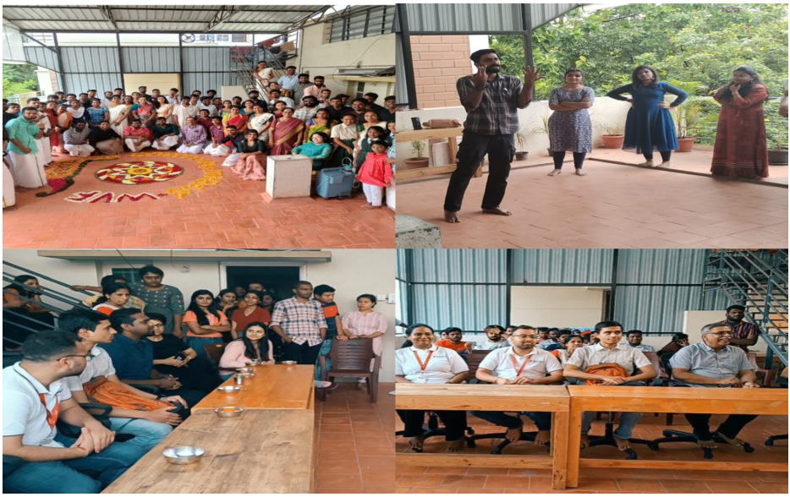

**Inclusive One day Trip**In October, WinVinaya organized a one-day trip to the enchanting Suggee Resort. It was an inclusive adventure where people with diverse abilities came together to create a day of fun and unforgettable memories. Over 75 people, some with disabilities and others without, were involved in this trip. The excitement continued with activities like dancing in the rain and thrilling adventures, including zip-lining, zorbing, rope walks, archery, Burma bridge, and even bull riding. What made that day truly extraordinary was the camaraderie and support shared among everyone. People with visual impairments ventured into mountain biking with guidance from their sighted friends, while those with hearing and speech impairments took the lead in the pool, teaching others how to swim.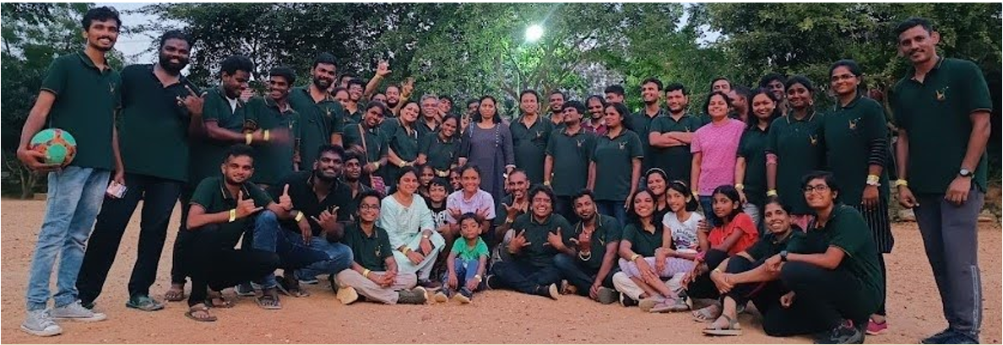

**MARGADARSHAN 2023 - JOB MELA**

MargaDarshan was more than a job fair; it was an inclusive team that orchestrated every aspect of the event. This included creating experiential zones, setting up the interview hall, stage, and registration desk. The team comprised individuals with diverse abilities — Hearing & Speech Impairment, Visual Impairment, Locomotor Disability, Neuro Diverse Spectrum, and those without disabilities. The event featured a panel discussion, Sensory Safari - Navigating Diversity with Persons with Visual Impairment, ISL Sprint - Introduction to Indian Sign Language, Neuro Embrace - Celebrating Neurodiversity, and an Assistive Technologies Showcase.

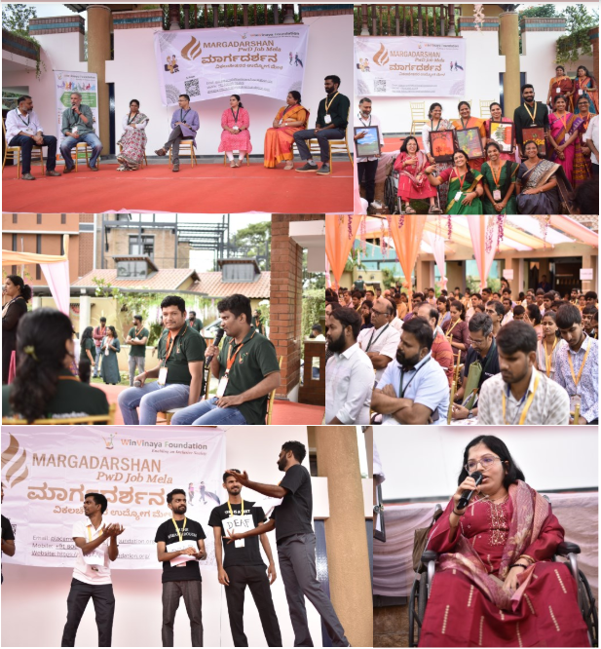 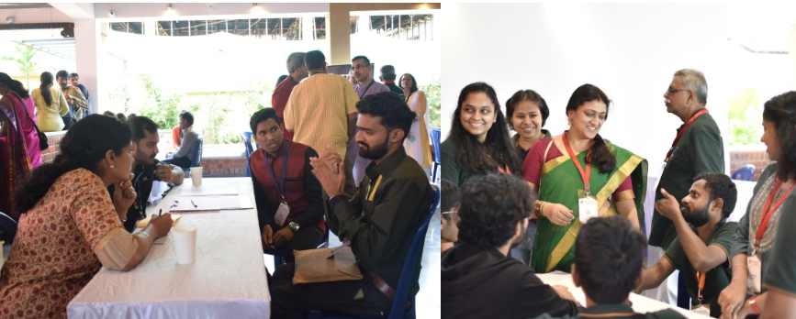 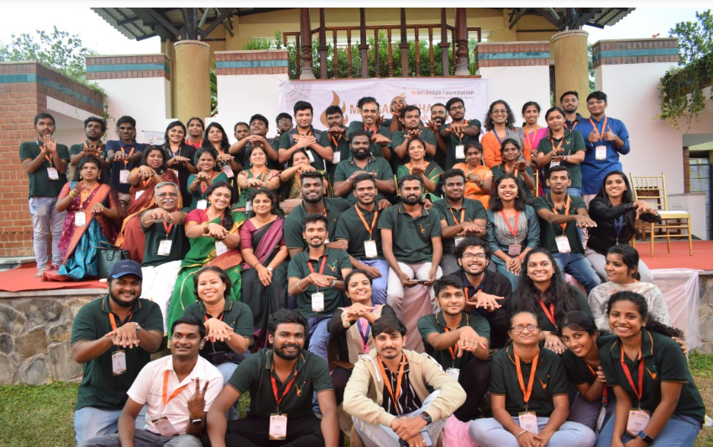

**WinVinaya Academy Won an Award for Innovation**

WinVinaya Academy was honored with the “Best Assistive Technology Initiative by NGOs Award” from ATF. WinVinaya Academy (WVA) provided 24/7 access to diverse courses such as full stack Software Development, Software Testing, Microsoft Power BI, MS Office, Tally, English, and more. WVA was inclusive, offering courses in Indian Sign Language and simple English to benefit people across disabilities, women, and other marginalized communities. WinVinaya Academy had 50+ courses and kept growing and improving. WinVinaya announced new Indian Sign Language (ISL) learning courses at WinVinaya Academy. Since 90% of its deaf candidates had hearing parents who didn’t know sign language, this course benefited a variety of stakeholders – including educators, parents, and corporate employees who wanted to learn the basics of ISL.

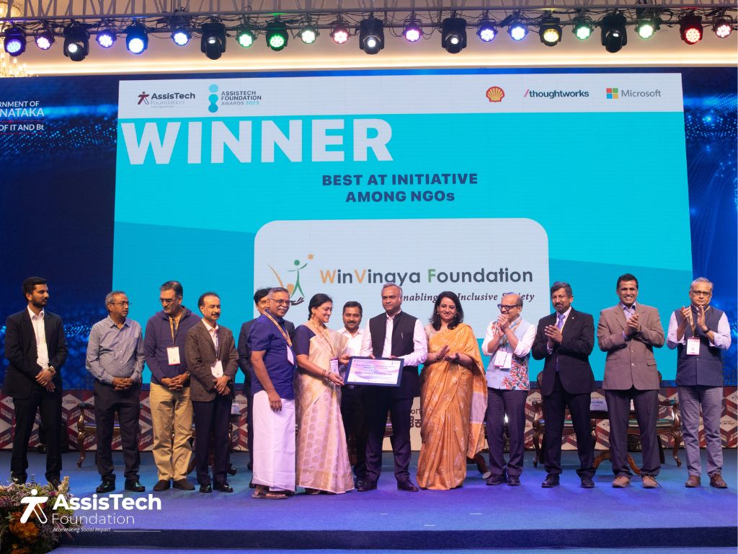

**Collaborating with IIITB on a Research Study**

WinVinaya Foundation, in collaboration with International Institute of Information Technology, (IIIT) Bengaluru, spearheaded a research study to explore the use of Android phones as Assistive Technology for individuals with disabilities. At Adarsh College, Bengaluru, WinVinaya team conducted a week-long training for students with hearing and speech impairment. Additionally, WinVinaya provided specialized training for persons with visual impairment who are first time smart phone users on how to use assistive technologies like talk back on smartphones. WinVinaya trained over 100 candidates and continued the training.

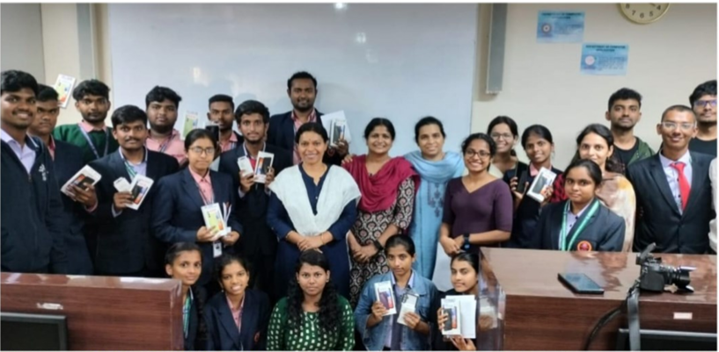

**MITRA RUN: AN INCLUSIVE MARATHON**

On December 3rd, in celebration of the International Day of Persons with Disabilities, WinVinaya actively participated in an inclusive marathon held at the Indian Institute of Management, Bengaluru, organized by the Eka Educational and Charitable Trust. 35 members from the WinVinaya Foundation participated in the 5K run, joined by individuals across various disabilities.

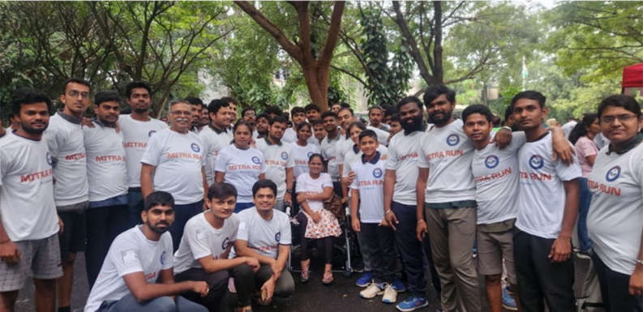

**Celebrating 7 Years of WinVinaya Foundation**

Over the past 7 years, WinVinaya Foundation has made a lasting impact. It trained over 1,100 candidates and placed more than 400 individuals, encompassing diverse disabilities and empowering women. To mark this milestone, WinVinaya conducted a workshop titled "Embracing WinVinaya Culture: I-We-Us". The workshop was attended by over 40 team members from various departments including sourcing, training, placement, and project management. Mr. Anand Vissa spearheaded this workshop for the WinVinaya Team.

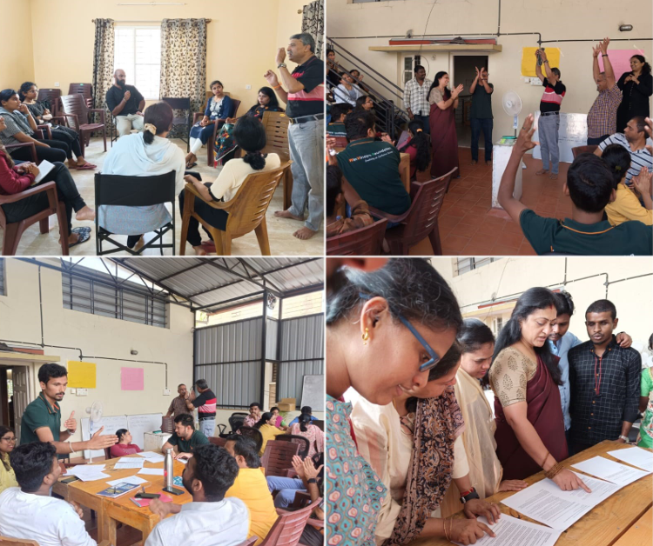

**Blood Donation Camp**

The blood donation camp was a testament to this ethos—a celebration of dignity, inclusivity, and community service associated with The Red Cross and the Rotary Abilities team. A total of 43 individuals from our community registered for the blood donation camp, showcasing remarkable enthusiasm and commitment. Among them, 27 participants generously donated blood to the blood bank.

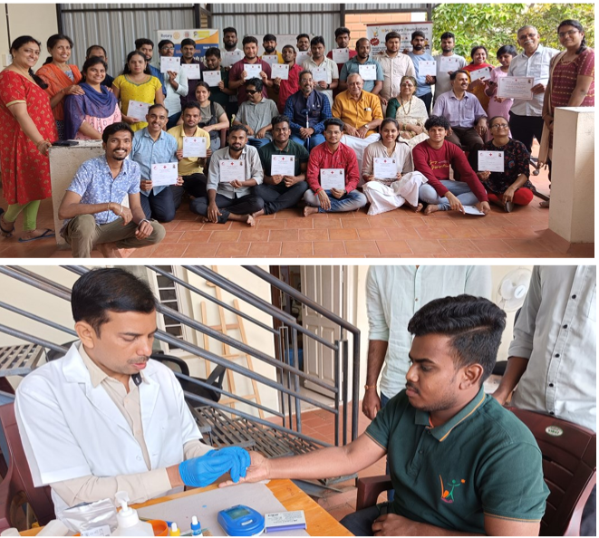

**InspireX Event**

WinVinaya attended InspireX, an event hosted by SVP India at Christ University, Bengaluru. WinVinaya participated in a session on fundraising strategies, which provided diverse perspectives on effective approaches for NGOs. WinVinaya had a stall at the event, offering experiential disability sensitization not only to students and professors but also to NGO partners and donors. Visitors immersed themselves in interactive activities, including a "Sensory Safari" where they played tactile chess blindfolded and engaged in a multi-sensory scavenger hunt using smell, taste, and hearing to identify hidden objects. As a highlight, participants dashed through an "ISL Sprint," learning basic Indian Sign Language phrases in just 15 minutes. It was a good opportunity for NGOs to connect, interact, and collaborate, making a more significant impact together.

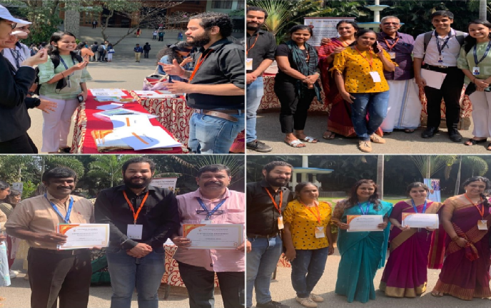

**‘GREAT PLACE TO WORK’ Recognition**

WinVinaya has been recognized as a "Great Place to Work" in the Non-Profit and Charity Organizations category.This recognition underscores its commitment to fostering a positive and inclusive workplace culture. By prioritizing employee well-being and professional development, WinVinaya continues to excel in creating a supportive environment for its team members.

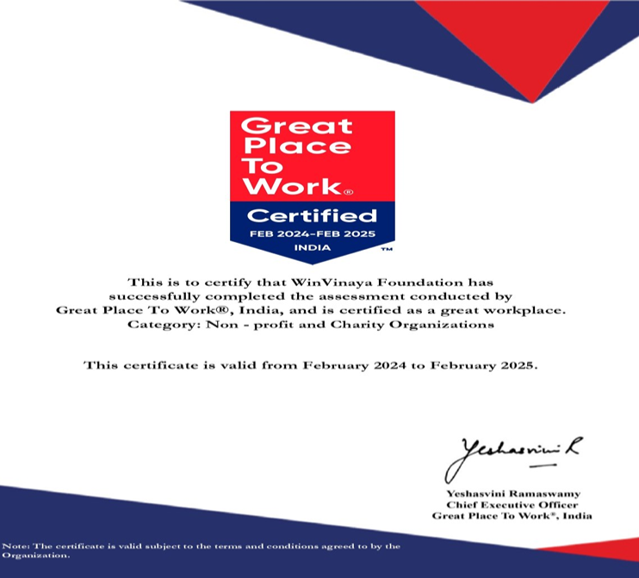

**SKATE SAFE-Workshop**

WinVinaya recently teamed up for a skating workshop on skating techniques. Stanley Ravi led an enlightening session, providing hands-on training on the basics of skating, including participants with Visual Impairment, Hearing and Speech Impairment, and those without disabilities. WinVinaya continued with follow-up sessions. Around 25+ members attended the orientation session, with 4 visually impaired and 4 hearing and speech impaired individuals, along with 2 non-PWDs, participating in subsequent sessions.

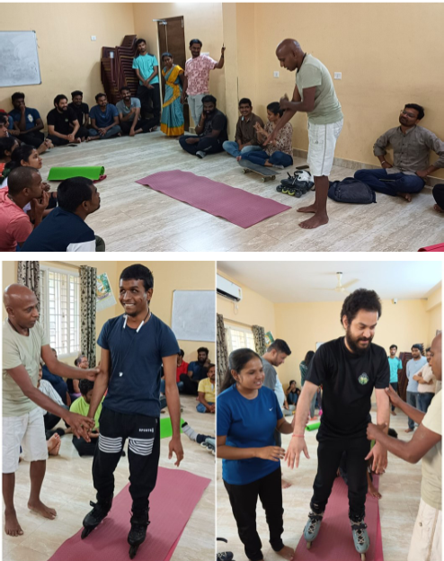

**Empowering Inclusivity: WinVinaya's impact at the Microsoft Meetup**

WinVinaya made significant waves at a Microsoft meetup, placing a spotlight on inclusivity and accessibility for individuals with disabilities. Attendees participated in an Indian Sign Language (ISL) sprint led by WinVinaya's deaf employees, gaining insights into the language and culture of the deaf community. WinVinaya's visually impaired employees showcased their remarkable skills through everyday tasks and strategic games tailored for their community. Arun Kumar S, one of WinVinaya's visually impaired employees, demonstrated the use of Microsoft Power BI with screen readers and keyboard shortcuts, highlighting the effectiveness of adaptive technology. WinVinaya gave insights into empowerment and advocacy for inclusivity within the community.

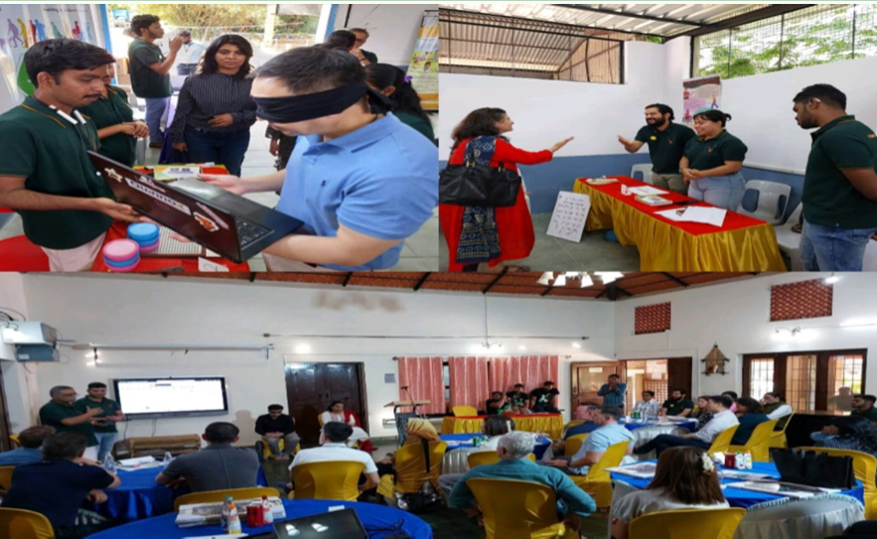

**WinVinaya goes Green: Sustainability Workshop**

WinVinaya Foundation hosted a captivating session on sustainable living led by environmentalists Ms. Mithan and Ms. Manisha. The session explored practical ways to embrace a greener lifestyle. Participants discovered easy changes they could incorporate into their routines to minimize environmental impact through Simple Swaps Daily Sustainability. They also learned effective methods to conserve and safeguard valuable water bodies in the Water Warriors segment. Additionally, participants got started with composting and unlocked the power of transforming kitchen scraps into nutrient-rich fertilizer for plants in Composting 101.

